- Account and User Management

UC1. Create a Personal Checking Account

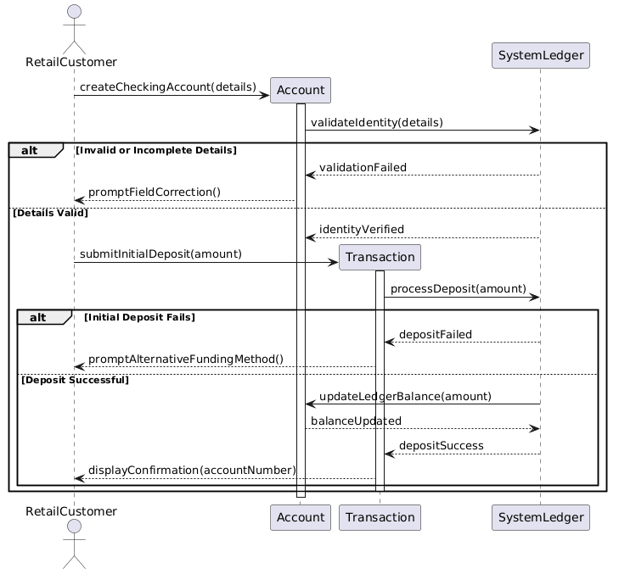
UC 02: Initiate Bulk Payroll Processing

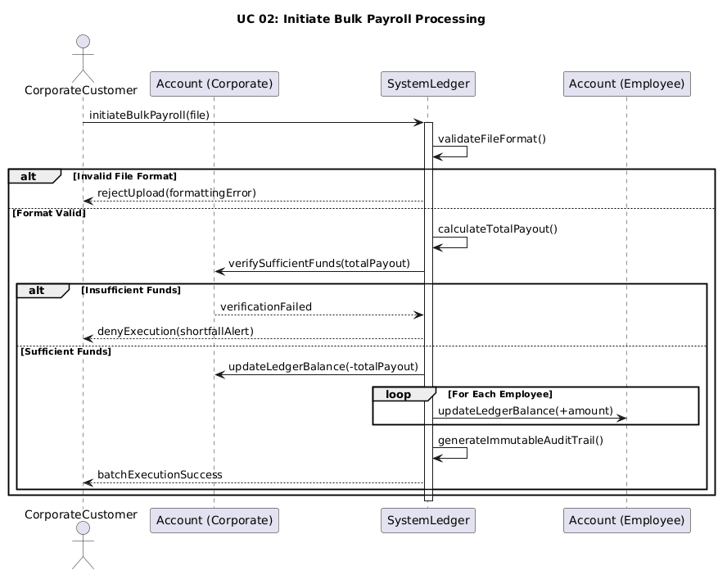
UC 03: Manage Multiple Authorized Signers

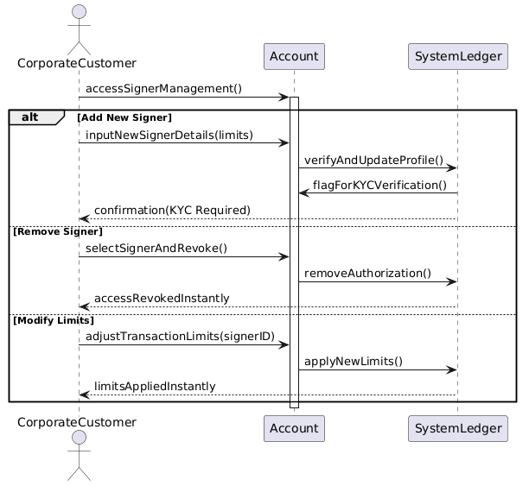
UC 04: Update KYC Documents
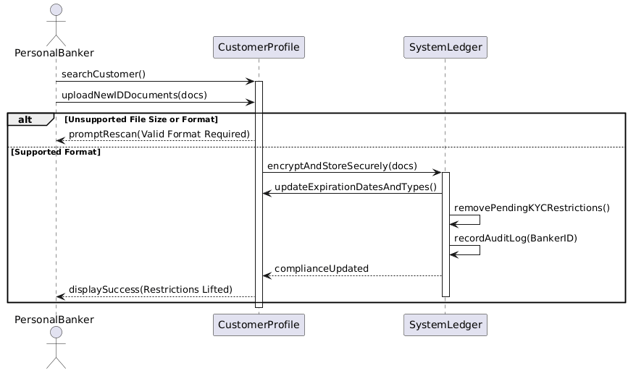
UC 05: Manage User Accounts (HR)

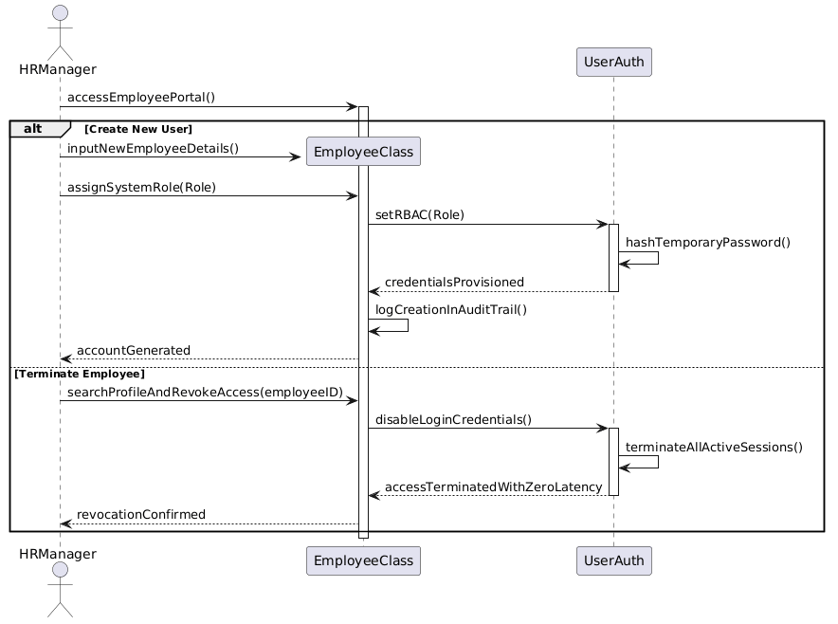
- Transactions and Cash Operations

UC 06: Process Cash Transactions
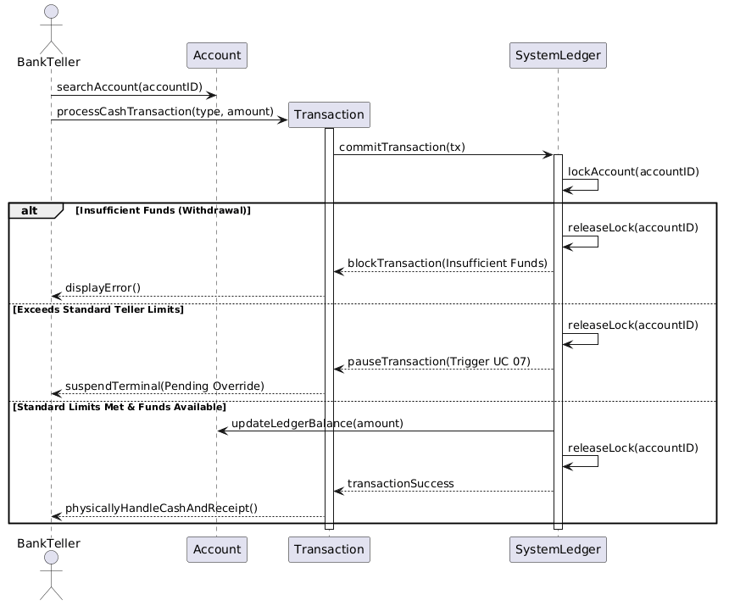

UC 07: Authorize Transaction Overrides
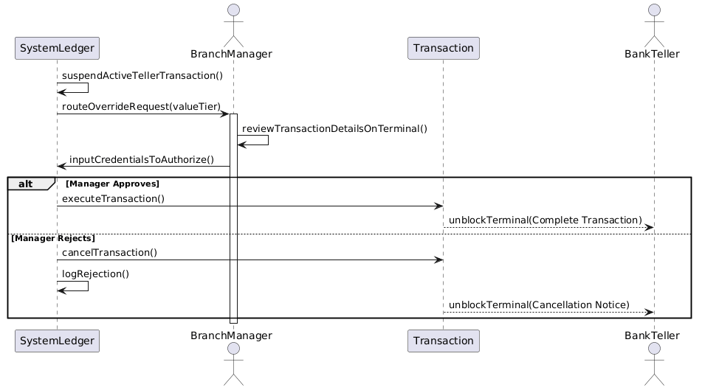
UC 08: Manage Branch Cash and Vault Operations
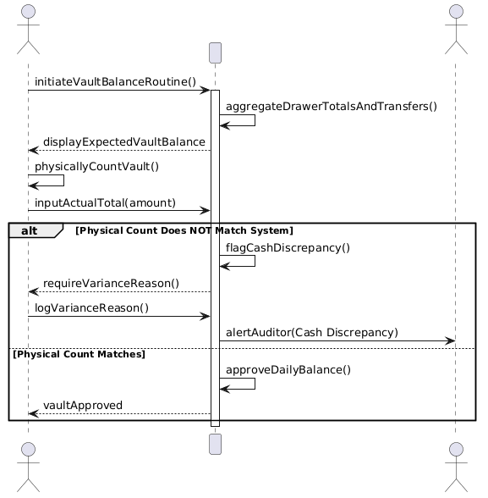
UC 09: Settle External Transfers
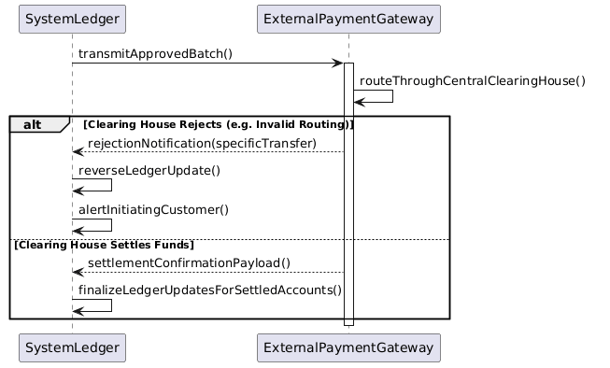

3. Credit & Loan Processing

UC 10: Evaluate Loan Applications
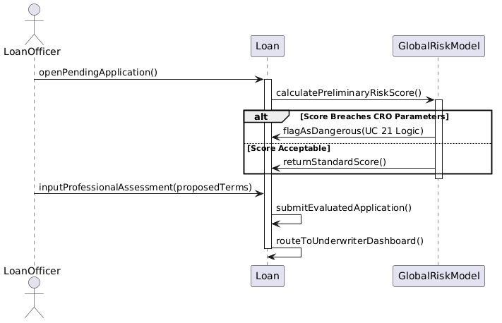
UC 11: Underwrite and Bind Loan Agreement
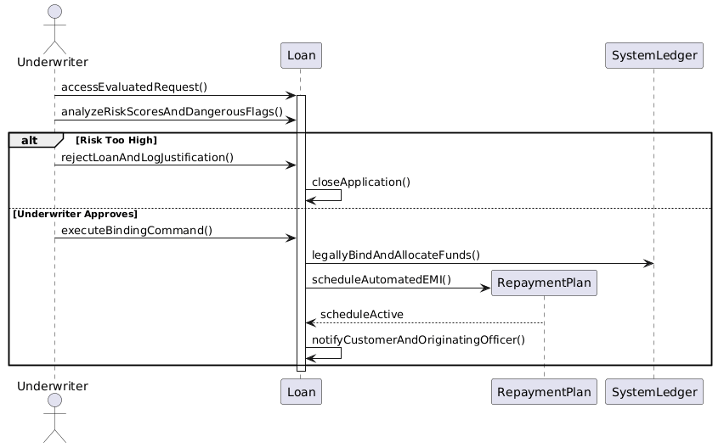
UC 12: Manage Defaulted Accounts and Asset Recovery
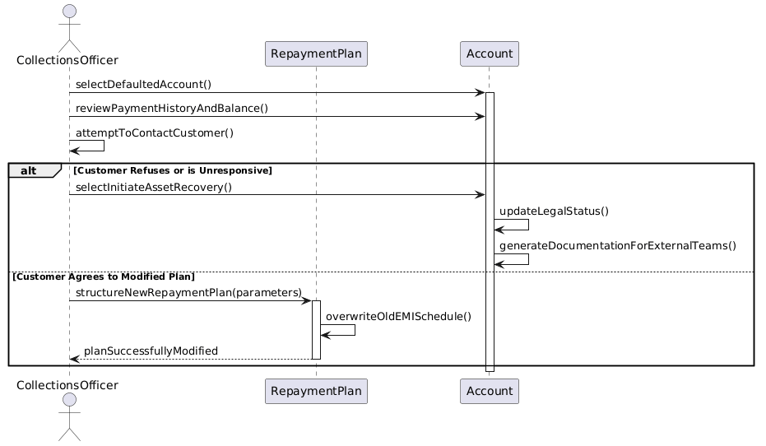

4. Monitoring, Security and Admin

UC 13: Monitor Transactions and Generate AML Reports
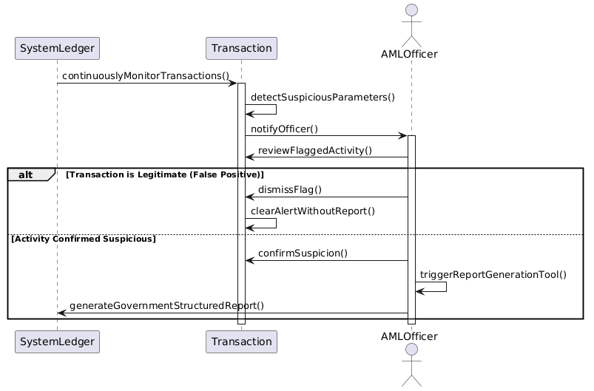
UC 14: View Action History and Audit Logs
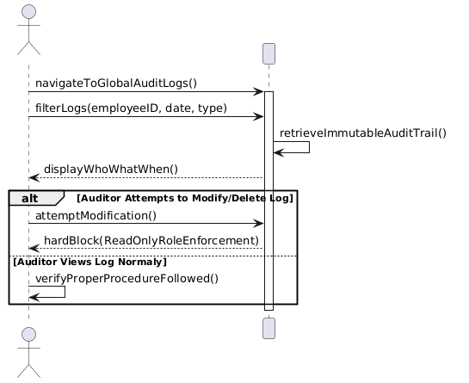
UC 15: View Profitability and Transaction Summaries
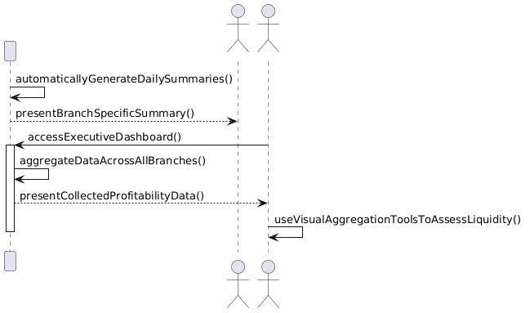
UC 16: Manage Core System Configurations and Backups
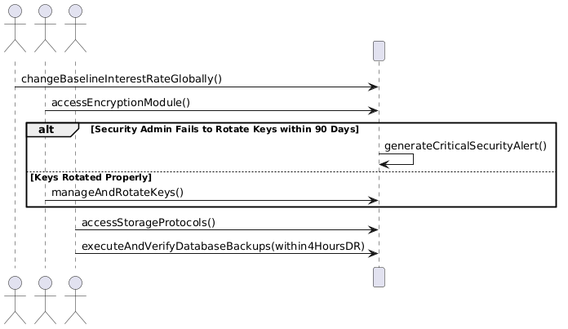

5. Remaining Core Operations & System Actors

UC 17: Generate Account Statements
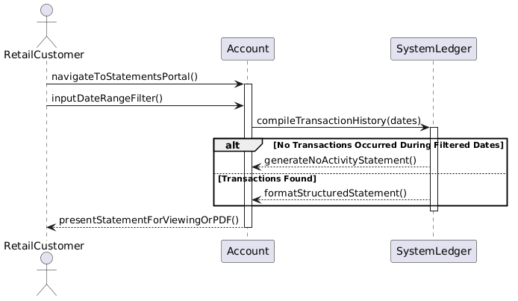
UC 18: Issue New Debit Card
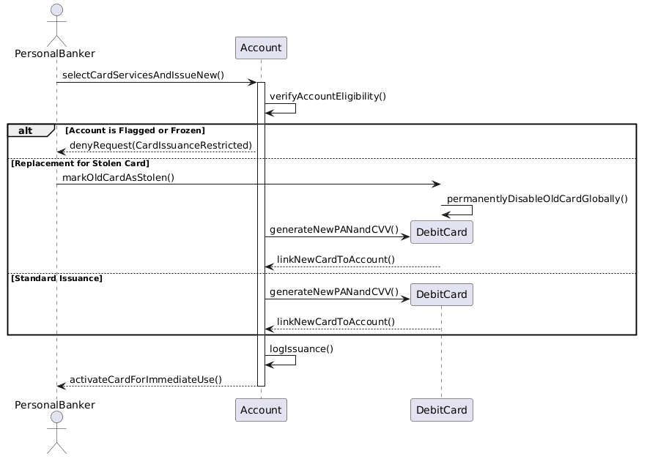
UC 19: Authenticate User
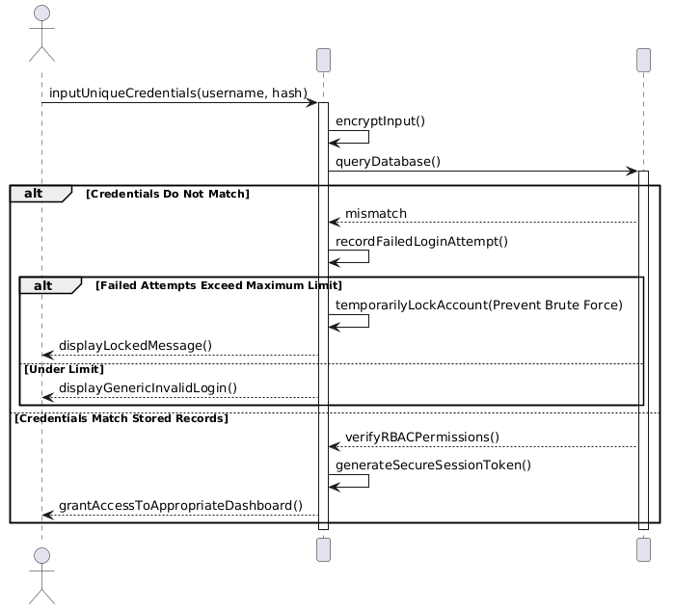
UC 20: Set Global Risk Parameters
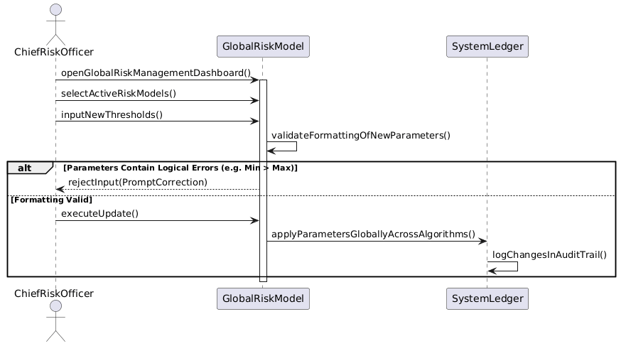
UC 21: Flag Dangerous Loans (System Actor)
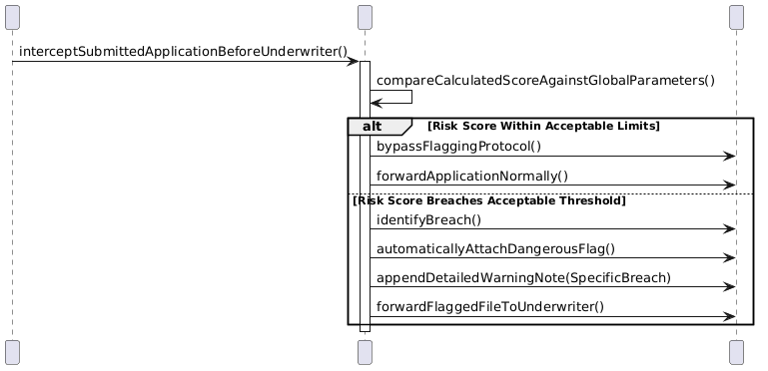
UC 22: Route Loan Requests (System Actor)
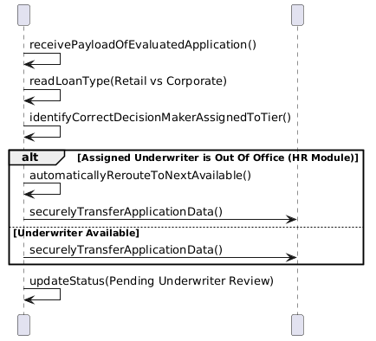
UC 23: Update Ledger Balances in Real-Time (System Actor)
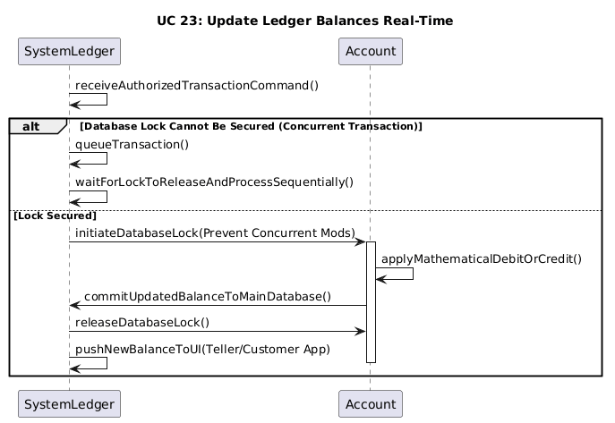
UC 24: Generate Daily Transaction Summaries (System Actor)
